CS 584-04: Machine Learning

Fall 2019 Assignment 1 [NAME – RAHUL NAIR (A20438470)]

ANSWER 1:

1. According to Izenman (1991) method, the recommended bin-width for the histogram for x should be:

$h=2\left(IQR\right)N^{-1/3}$

where:

h: bin-width

IQR: Inter-Quartile range

N: Total number of Observations

Now, in this problem the recommended bin-width would be 40.01332889135637.

1. Minimum value of Field x: 26.3

Maximum value of Field x: 35.3

1. Value of a: 26

Value of b: 36



m(i) p(i)

26.05 0.0

26.150000000000002 0.0

26.250000000000004 0.00999000999000999

26.350000000000005 0.0

26.450000000000006 0.0

26.550000000000008 0.0

26.65000000000001 0.0

26.75000000000001 0.0

26.850000000000012 0.0

26.950000000000014 0.0

27.050000000000015 0.0

27.150000000000016 0.00999000999000999

27.250000000000018 0.0

27.35000000000002 0.0

27.45000000000002 0.0

27.550000000000022 0.0

27.650000000000023 0.01998001998001998

27.750000000000025 0.0

27.850000000000026 0.02997002997002997

27.950000000000028 0.00999000999000999

28.05000000000003 0.00999000999000999

28.15000000000003 0.049950049950049945

28.250000000000032 0.02997002997002997

28.350000000000033 0.01998001998001998

28.450000000000035 0.03996003996003996

28.550000000000036 0.03996003996003996

28.650000000000038 0.049950049950049945

28.75000000000004 0.07992007992007992

28.85000000000004 0.049950049950049945

28.950000000000042 0.049950049950049945

29.050000000000043 0.03996003996003996

29.150000000000045 0.10989010989010987

29.250000000000046 0.14985014985014983

29.350000000000048 0.07992007992007992

29.45000000000005 0.13986013986013984

29.55000000000005 0.1898101898101898

29.650000000000052 0.0899100899100899

29.750000000000053 0.09990009990009989

29.850000000000055 0.20979020979020976

29.950000000000056 0.15984015984015984

30.050000000000058 0.14985014985014983

30.15000000000006 0.21978021978021975

30.25000000000006 0.14985014985014983

30.350000000000062 0.2797202797202797

30.450000000000063 0.23976023976023975

30.550000000000065 0.1898101898101898

30.650000000000066 0.2697302697302697

30.750000000000068 0.19980019980019978

30.85000000000007 0.19980019980019978

30.95000000000007 0.16983016983016982

31.05000000000007 0.15984015984015984

31.150000000000073 0.2797202797202797

31.250000000000075 0.20979020979020976

31.350000000000076 0.2797202797202797

31.450000000000077 0.33966033966033965

31.55000000000008 0.2597402597402597

31.65000000000008 0.33966033966033965

31.75000000000008 0.2697302697302697

31.850000000000083 0.19980019980019978

31.950000000000085 0.33966033966033965

32.05000000000008 0.24975024975024973

32.15000000000009 0.3196803196803197

32.250000000000085 0.1898101898101898

32.350000000000094 0.23976023976023975

32.45000000000009 0.2797202797202797

32.5500000000001 0.22977022977022976

32.65000000000009 0.29970029970029965

32.7500000000001 0.21978021978021975

32.850000000000094 0.15984015984015984

32.9500000000001 0.1898101898101898

33.0500000000001 0.13986013986013984

33.150000000000105   0.12987012987012986

33.2500000000001 0.15984015984015984

33.35000000000011 0.05994005994005994

33.4500000000001 0.10989010989010987

33.55000000000011 0.05994005994005994

33.650000000000105 0.06993006993006992

33.750000000000114 0.05994005994005994

33.85000000000011 0.06993006993006992

33.95000000000012 0.02997002997002997

34.05000000000011 0.03996003996003996

34.15000000000012 0.049950049950049945

34.250000000000114 0.02997002997002997

34.35000000000012 0.00999000999000999

34.45000000000012 0.01998001998001998

34.550000000000125 0.01998001998001998

34.65000000000012 0.00999000999000999

34.75000000000013 0.00999000999000999

34.85000000000012 0.00999000999000999

34.95000000000013   0.0

35.050000000000125 0.0

35.150000000000134 0.0

35.25000000000013 0.00999000999000999

35.350000000000136 0.00999000999000999

35.45000000000013 0.0

35.55000000000014   0.0

35.650000000000134 0.0

35.75000000000014 0.0

35.850000000000136   0.0



m(i) p(i)

26.25 0.001998001998001998

26.75 0.0

27.25 0.001998001998001998

27.75 0.011988011988011988

28.25 0.03196803196803197

28.75 0.061938061938061936

29.25 0.11388611388611389

29.75 0.17782217782217782

30.25 0.23976023976023977

30.75 0.25374625374625376

31.25 0.28771228771228774

31.75 0.34965034965034963

32.25 0.32367632367632365

32.75 0.2757242757242757

33.25 0.15784215784215785

33.75 0.07992007992007992

34.25 0.03596403596403597

34.75 0.013986013986013986

35.25 0.003996003996003996





m(i) p(i)

26.5 0.000999000999000999

27.5 0.006993006993006993

28.5 0.04295704295704296

29.5 0.13186813186813187

30.5 0.22277722277722278

31.5 0.28471528471528473

32.5 0.27172827172827174

33.5 0.10789210789210789

34.5 0.022977022977022976



m(i) p(i)

26.5 0.000999000999000999

27.5 0.006993006993006993

28.5 0.04295704295704296

29.5 0.13186813186813187

30.5 0.22277722277722278

31.5   0.28471528471528473

32.5 0.27172827172827174

33.5 0.10789210789210789

34.5 0.022977022977022976

1. In my opinion, the histogram with bin-width 0.5 will provide us with more insights into the shape and distribution of the field x. As we can see in the histogram and density estimations, the histogram with bin-width 0.1 is erratically distributed and when it comes to histograms with bin-widths 1 and 2 don’t give us much insights. So with proper balance between the marginalized distribution of data histogram with bin-width 0.1 is the best in these list.

ANSWER 2:

1. Five- point summary of x:

Minimum value = 26.3

First Quartile = 30.4

Median = 31.5

Third Quartile = 32.4

Maximum value = 35.4

Values of 1.5 IQR whiskers:

Q1- 1.5*IQR = minimum value = 27.4

Q3+1.5*IQR = maximum value = 35.4

1. Five- point summary of group 0:

Minimum value = 26.3

First Quartile = 29.4

Median = 30

Third Quartile = 30.6

Maximum value = 32.2

Values of 1.5 IQR whiskers:

Q1- 1.5*IQR = minimum value = 27.6

Q3+1.5*IQR = maximum value = 32.4

Five- point summary of group 1:

Minimum value = 29.1

First Quartile = 31.4

Median = 32.1

Third Quartile = 32.7

Maximum value = 35.4

Values of 1.5 IQR whiskers:

Q1- 1.5*IQR = minimum value = 29.45

Q3+1.5*IQR = maximum value = 34.65

1. Boxplot:

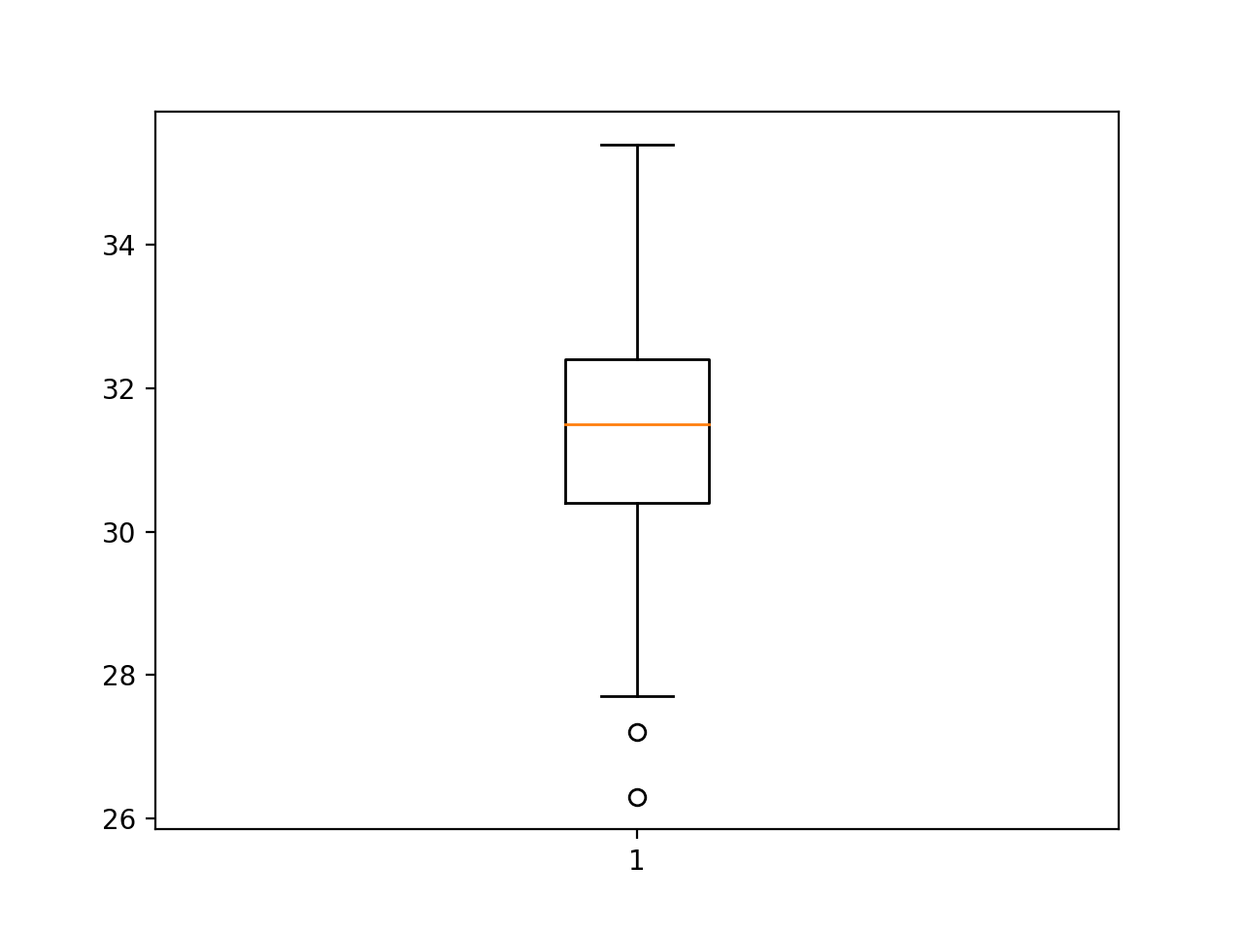

The 25th percentile value of the data is 30.4. When we apply 1.5 IQR whiskers, the answer is 27.4 which is precisely shown by python boxplot.

The 75th percentile of the data is 32.4. When we apply 1.5 IQR whiskers, the answer is 35.4 which is the same as that calculated by python. So, it is exactly correct.

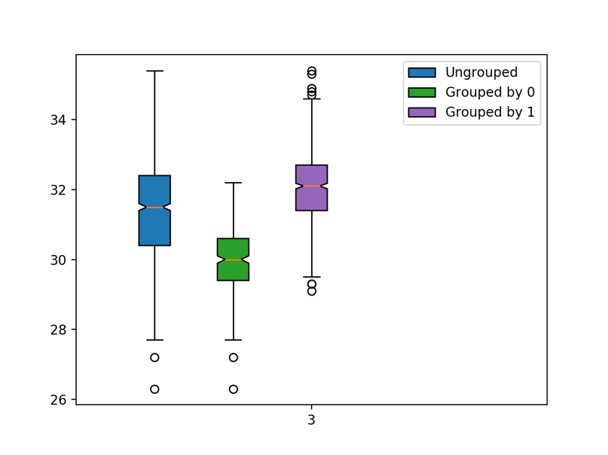

For the general data (Ungrouped), the ouliers found using 1.5 whiskers are:-

27.21

26.28

For the data which are grouped by 0, the outliers found using 1.5 whiskers are:-

27.21

26.28

For the data which are grouped by 1, the outliers found using 1.5 whiskers are:-

29.33

29.1

35.39

35.28

34.88

34.77

34.70

34.66

ANSWER 3:

1. Percentage of investigations found to be fraudulent are: 19.9497%
2. For ‘TOTAL_SPEND’:



FOR ‘DOCTOR_VISITS’:



FOR ‘NUM_CLAIMS’:



FOR ‘MEMBER_DURATION’:



FOR ‘OPTOM_PRESC’:



FOR ‘NUM_MEMBERS’:



1. (i) Number of Dimensions used: 6

(ii) Transformation matrix:

[[-6.49862374e-08 -2.41194689e-07 2.69941036e-07 -2.42525871e-07

-7.90492750e-07 5.96286732e-07]

[ 7.31656633e-05 -2.94741983e-04 9.48855536e-05 1.77761538e-03

3.51604254e-06 2.20559915e-10]

[-1.18697179e-02 1.70828329e-03 -7.68683456e-04 2.03673350e-05

1.76401304e-07 9.09938972e-12]

[ 1.92524315e-06 -5.37085514e-05 2.32038406e-05 -5.78327741e-05

1.08753133e-04 4.32672436e-09]

[ 8.34989734e-04 -2.29964514e-03 -7.25509934e-03 1.11508242e-05

2.39238772e-07 2.85768709e-11]

[ 2.10964750e-03 1.05319439e-02 -1.45669326e-03 4.85837631e-05

6.76601477e-07 4.66565230e-11]]

We can prove that the resulting variables are orthonormal if the multiplication of transpose of the transformed matrix and the transformed matrix gives us an identity

matrix which is:

[[ 1.00000000e+00 -2.87703888e-15 1.90299165e-15 7.06552872e-15

1.16226473e-15 -1.35308431e-16]

[-2.87703888e-15 1.00000000e+00 -1.37216627e-15 -1.98244199e-14

-6.59194921e-16 7.21644966e-16]

[ 1.90299165e-15 -1.37216627e-15 1.00000000e+00 4.96366728e-15

-6.24500451e-17 -1.17961196e-16]

[ 7.06552872e-15 -1.98244199e-14 4.96366728e-15 1.00000000e+00

1.10432496e-14 -4.20496971e-15]

[ 1.16226473e-15 -6.59194921e-16 -6.24500451e-17 1.10432496e-14

1.00000000e+00 -6.66133815e-16]

[-1.35308431e-16 7.21644966e-16 -1.17961196e-16 -4.20496971e-15

-6.66133815e-16 1.00000000e+00]]

Therefore, the resulting variables are orthonormal.

1. i) the score value is 0.8778523489932886.

ii) The score function is showing the accuracy of the model. It depicts that the model is correct about 87% of the time. This is a pretty good accuracy rate for a model.

1. The five neighbors are:-



1. The predicted probability of the fraudulent is 100%.

The predicted probability of the fraudulent is greater than the answer we found in a) part. Based on the criterion this will be classified as fraudulent, but this observation will be misclassified. Since the accuracy of the model is 87.79%(approx), we still cannot be sure whether the model is correct in classifying it as fraudulent.